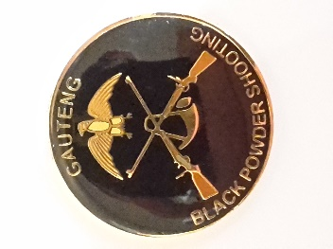
Gauteng Black Powder Provincial Championship 2018
Venue: Mariette Black Powder Shooting Range
1 December 2018 08:00

Name…………………………………………………….. Contact Nr………………………………………………………
Club……………………………………………………….. SABU Nr………………………………………………………….

100m Events
Whitworth (Free Rifle) ………. Minie (Military Rifle) ……….
Hawken (Traditional or Mod) ………. Inlines (Rolling Block etc) ……….
Free Breech Loader ………. SBBL (Martini Henry) ……….
50m Events
Vetterli (Free Rifle Off-hand) ………. Lamarmora (Military Rifle Off-hand) ……….
Hawken (Traditional or Mod) ………. Inlines (Rolling Block etc) ………..
Donald Malson (Revolver) ……….
25m Events
Kuchenreuter (Single Shot Pistol) ………. Mariette (Revolver) ……….
Classic Handgun ……….

Entry Fee: The entry fee will be R 275.00 ,which will include all events. Please pay into bank account
below as we do not want to handle cash on the day.
Banking details: FNB, Savings, Acc #: 62526615127, Acc holder: Jacques Jansen van Vuuren
Branch code: 250655. (Please use name as reference).
Please forward Entry Form and Proof of payment to: jacquesjvv.optom@vodamail.co.za ASAP.
A prizegiving will be held early in 2019 depending on the amount of participants and entries.
Please stay afterwards to socialise . A cash bar will be available.

